Control Systems Lab

Lab 6 In-Class: DC Motor Speed Control

Objectives
- Experimentally test proportional, pure integral, and PI (proportional plus integral) compensation for speed control of a DC motor

Overview
In this lab you will test the compensators designed in the prelab. You will be required to apply tools and experience learned in previous labs, so not all methods will be explicitly described in the instructions. For example, you will need to modify a Simulink diagram, and analyze and plot data.

Experiments
You will be performing 4 experiments total. Be sure to save the data for each experiment. In the graphs for each experiment, you will want to plot a response similar to what you would predict from SISOtool (illustrated below), including the reference signal and the actual response. Zoom in enough to capture the overshoot and the steady state response (with axis labels, units, and legend, of course!).
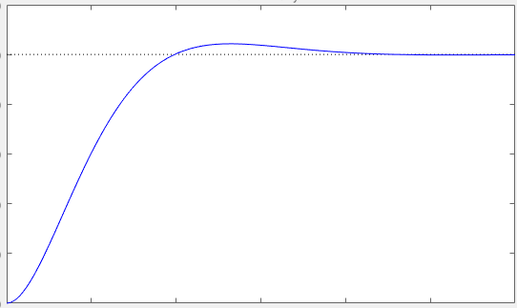

Part 1: Proportional Control
- Download the Simulink model from LMS and test proportional speed control with $K_{pmax}$ determined in prelab. Use a reference of 155 rad/sec. Upload a graph of the reference signal and the response along with the .mat data file to Gradescope. How does the steady state error compare to what you calculated in the prelab (take note here – you do not have to answer this in Gradescope)?

- The steady state error is likely larger than you calculated due to the motor friction. Since it is known that the motor does not spin until 0.5 volts, one way to address this is to always add 0.5 volts to the system all the time. You can do this by adding a constant 0.5 V to the voltage right before it goes into the motor. (You will keep this offset for the remaining experiments.) Now run the same proportional controller. Upload a graph of the reference signal and the response along with the .mat data file to Gradescope. What is the steady error now (just take note here – you do not have to enter it in Gradescope)?

Part 2: Addressing steady-state error with a pure integrator
Save the Simulink diagram with a new name for testing integral control. Modify the Simulink diagram to include a pure integrator. Use the gain you designed in the prelab for $ζ=$0.591. Run the compensator. Upload a graph of the reference signal and the response along with the .mat data file to Gradescope.

Part 3: Addressing transient response with a zero
Save the Simulink diagram with a new name for testing the next compensator. Modify the Simulink diagram to include a zero in the compensator. Use the compensator you designed in the prelab for $ζ=$0.591 with improved settling time. Run the compensator. Upload a graph of the reference signal and the response along with the .mat data file to Gradescope. Include a screenshot of your final Simulink diagram.

